**Laboratório Banco de Dados**

**Lista de Exercícios – Aula 04**

**O modelo abaixo representa um diagrama de banco de dados de vendas**

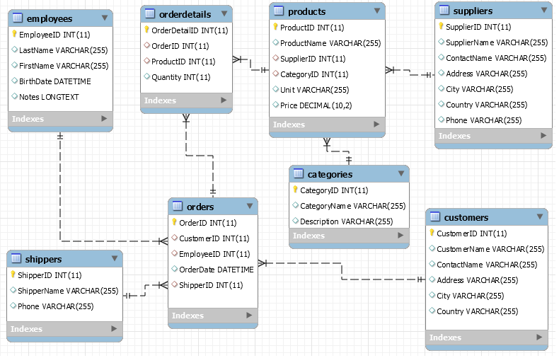

1. Criar Views para todas consultas abaixo:

Select

o.orderId, o.orderDate, e.firstName -- , d.productId, d.quantity, p.price

, SUM(d.quantity * p.price) as Total

FROM

Orders o

Inner Join Employees e ON (e.employeeId = o.employeeId)

Inner Join OrderDetails d ON (d.orderId = o.orderId)

Inner Join Products p ON (p.productId = d.productId)

GROUP BY o.orderId, o.orderDate, e.firstName

ORDER BY Total DESC

SELECT

o.OrderID, o.OrderDate, e.FirstName

,p.ProductName, c.CategoryName, d.Quantity , p.Price

,d.Quantity * p.Price As 'Total Produto'

FROM

Orders o

Inner JOIN Employees e On (e.EmployeeID = o.EmployeeID)

Inner JOIN OrderDetails d On (d.orderid = o.orderid)

Inner JOIN Products p ON (p.ProductID = d.ProductID )

Inner JOIN Categories c ON (c.CategoryID = p.CategoryID)

SELECT

c.customername,

SUM(d.Quantity * p.Price) as 'Total de Vendas',

AVG(d.Quantity * p.Price) as 'Média de Vendas'

FROM

Orders o

INNER JOIN OrderDetails d ON (d.OrderID= o.OrderID)

INNER JOIN Customers c ON (c.CustomerID = o.CustomerID )

INNER JOIN Products p ON (p.ProductID = d.ProductID)

GROUP BY c.customername

ORDER BY 3 DESC

SELECT

c.categoryname,

SUM(d.Quantity * p.Price) as 'Total de Vendas',

AVG(d.Quantity * p.Price) as 'Média de Vendas'

FROM

OrderDetails d

INNER JOIN Products p ON (p.ProductID = d.ProductID)

INNER JOIN Categories c ON (c.categoryid = p.categoryid )

GROUP BY c.categoryname

ORDER BY 3 DESC

SELECT

e.LastName+', '+e.FirstName as 'Empregado',

SUM(d.Quantity * p.Price) as 'Total de Vendas',

AVG(d.Quantity * p.Price) as 'Média de Vendas'

FROM

Orders o

INNER JOIN OrderDetails d ON (d.OrderID= o.OrderID)

INNER JOIN Employees e ON (e.employeeid = o.employeeid )

INNER JOIN Products p ON (p.ProductID = d.ProductID)

GROUP BY e.LastName+', '+e.FirstName

ORDER BY 3 DESC

SELECT

s.ShipperName,

SUM(d.Quantity * p.Price) as 'Total de Vendas',

AVG(d.Quantity * p.Price) as 'Média de Vendas'

FROM

Orders o

INNER JOIN OrderDetails d ON (d.OrderID= o.OrderID)

INNER JOIN Shippers s ON (s.ShipperID= o.ShipperID)

INNER JOIN Products p ON (p.ProductID = d.ProductID)

GROUP BY s.ShipperName

ORDER BY 3 DESC

SELECT

p.productname,

SUM(d.Quantity * p.Price) as 'Total de Vendas',

AVG(d.Quantity * p.Price) as 'Média de Vendas'

FROM

OrderDetails d

INNER JOIN Products p ON (p.ProductID = d.ProductID)

GROUP BY p.productname

ORDER BY 3 DESC

SELECT

s.ShipperName,

p.ProductName,

SUM(d.Quantity * p.Price) as 'Total de Vendas'

FROM

Orders o

INNER JOIN OrderDetails d ON (d.OrderID= o.OrderID)

INNER JOIN Shippers s ON (s.ShipperID= o.ShipperID)

INNER JOIN Products p ON (p.ProductID = d.ProductID)

GROUP BY s.ShipperName, p.ProductName

ORDER BY 'Total de Vendas' DESC

SELECT

YEAR(o.OrderDate) AS 'Ano',

MONTH(o.OrderDate) AS 'Mês',

AVG(d.Quantity * p.Price) as 'Média de Vendas'

FROM

Orders o

INNER JOIN OrderDetails d ON (d.OrderID= o.OrderID)

INNER JOIN Products p ON (p.ProductID = d.ProductID)

GROUP BY YEAR(o.OrderDate),MONTH(o.OrderDate)

ORDER BY 'Ano' DESC,'Mês' DESC

select

DATEPART(mm,OrderDate),Month(Orderdate) as mes

,DATEPART(dy,OrderDate) as 'dia do ano'

,DATEPART(dy,GetDate()) as 'dia do ano atual'

,DATEPART(dw,GetDate()) as 'dia da semana'

,DATEPART(day,GetDate()) as 'dia'

from Orders